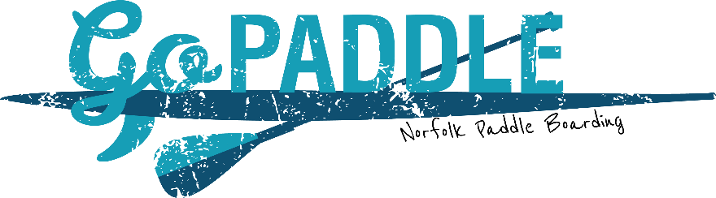

Awareness of risk and informed consent

If under eighteen this form must be read and signed by a parent or guardian of the participating young person on their behalf. It is the responsibility of the parent/guardian to ensure that the young person is aware of the risks involved in participating in adventurous activities, and that they understand the importance of the following terms. In consideration of being allowed to participate in the activities of Go Paddle (trading as Go Paddle) and to use the facilities and equipment owned and/or under the control of Go Paddle, in addition to the payment of any fee or charge, I understand and I am aware that paddle sports and outdoors activities are potentially hazardous activities. I also understand that paddle sports and outdoors activities can involve a risk of injury and even death, and that I am voluntarily participating in these activities and using equipment and facilities with the knowledge of the dangers involved. I hereby agree to expressly assume and accept all and any risks of injury or death. I am aware that I have the right to request advice from any of the Go Paddle instructors, at any time, in relation to the activities being undertaken and, but not exclusively, their suitability for me, with particular regard to my health and clothing. If I choose not to take advice, or to disregard any advice so given, I do so voluntarily and accept liability for all resulting injuries or damage. I do hereby declare myself to be physically sound and suffering from no condition, impairment, disease or infirmity or other illness (other than those declared on the attached Booking Form) that would prevent my participation or use of equipment or facilities except as herein stated. I acknowledge that I have either had a physical examination and have been given my doctor’s permission to participate, or that I have decided to participate in activity and use of equipment without the approval of my doctor and do hereby assume all responsibility for my participation and activities, and utilisation of equipment in my activities. I consent to my personal contact details (name and phone number/s) to be circulated to the appropriate Go Paddle instructor team. I also consent to the contact details of my Emergency Contact (name and phone number/s) to be used by the appropriate Go Paddle instructor team and Go Paddle Owner if necessary. I will ensure that I am fully prepared for my activity day, bringing appropriate clothing and footwear for the activities I am participating in and the weather conditions, plus a full change of clothes and any medication I may need. Whilst under Go Paddleboarding’s instruction, I will listen carefully to and abide by all oral instructions and rules given to me by Go Paddle Staff Members. I understand that failure to do so may result in an accident. I agree to wear all safety equipment provided by Go Paddle in the manner demonstrated by Go Paddle Staff. I understand that certain elements of participation in outdoor activities will involve physically challenging activities. I acknowledge that I am responsible for my own behaviour whilst under Go Paddleboarding’s instruction. Offensive, aggressive or disruptive behaviour will result in the participant leaving the session, or premises. I acknowledge that I am also responsible for my own possessions whilst under Go Paddle instruction, Go Paddle cannot accept responsibility for valuables l leave whilst out paddleboarding. We advise that valuable possessions are left at home. By signing the form, you consent to Go Paddle using any media (including photographs and/or video footage) made of you during the event which may or may not encompass intellectual property rights belonging to you and that these images may be used by Go Paddle for publicity and training purposes including, but not limited to: in brochures, social media, websites, marketing material and in the press. If you do not wish for your image to be used you must inform Go Paddle, in writing, at the time of agreeing to these terms.

